Contents
I. Objective, Purpose 3
II. Application Overview 3
III. Testing Scope 3
IV. Test cases 4
Login Functionality 4
Logout Functionality 5
Navigation Functionality 5
Registration Functionality 6
Search Functionality 8
Add-to-Cart Functionality 9
Checkout Functionality 11
V. Test Case Summary Report 13
1. Metrics 13

- Objective, Purpose
Objective
To develop automated test scripts using Selenium for testing web application functionalities, execute these scripts, and generate comprehensive test reports.

Purpose
To ensure the functionality, usability, performance, and security of the clothes and household selling website meet the specified requirements and provide a seamless shopping experience for users.

- Application Overview
The website allows users to browse, search, and purchase a variety of clothing items and household products. Key features include user registration, logging in/out, shopping cart functionality and payment processing.

- Testing Scope
The testing will cover
- User registration and log in/out
- Product search functionality
- Shopping cart functionality
- Add-to-Cart functionality
- Payment gateway integration
- Navigation

Out of Scope
- Responsive design across devices
- Security and performance testing

- Test Cases:
- Login_logout.py

Test case ID | Description | Steps | Expected Result
TC01 | Test valid login | - Navigate to http://127.0.0.1:8000/  - Click “Login”  - Enter email address  - Enter password  - Click “LOG IN” | User is logged in, and navigate to the dashboard
TC02 | Test invalid password | - Navigate to http://127.0.0.1:8000/  2. Enter email address  3. Enter wrong password  4. Click “Submit” | The website show the error “Passwords do not match.”
TC03 | Test invalid email address | 1. Navigate to http://127.0.0.1:8000/  2. Enter wrong email address  3. Enter wrong password  4. Click “Submit” | The website show the error “Email Address does not match.”
TC04 | Test valid logout | - Navigate to http://localhost/eCommerceSite-PHP/login.php  - Click “Submit” | The website show the error “Email and/or Password can not be empty.”

Logout Functionality

Test case ID | Description | Steps | Expected Result
TC005 | Test logout | - Navigate to http://localhost/eCommerceSite-PHP/login.php  - Enter email address  - Enter pasword  - Click “Submit”  - Click “Logout” | User is logged out and back to the login page

Navigation Functionality

Test case ID | Description | Steps | Expected Result
TC006 | Test the navigation | - Navigate to http://localhost/eCommerceSite-PHP/index.php  ( Check the title and the URL of each page)  - Click “About Us”  - Click “FAQ”  - Click “Contact Us”  - Click “FAQ”  - Click “Home” | The title and URL of each page are completely right

Registration Functionality

Test case ID | Description | Steps | Expected Result
TC007 | Test the navigation | - Navigate to http://localhost/eCommerceSite-PHP/registration.php  - Enter fullname  - Enter company name  - Enter email address  - Enter phone  - Enter address  - Choose country  - Enter city  - Enter state  - Enter zip code  - Enter password  - Retype password  - Click “Register”  (There is a major error about the mail() method in PHP, but it did not affect the execution) | The website show the message “Your registration is completed. Please check your email address to follow the process to confirm your registration.”
TC008 | Test existed email | - Navigate to http://localhost/eCommerceSite-PHP/registration.php  - Fill all required fields and enter an existed email  - Click “Submit” | The website show the error “Email Address Already Exists”
TC009 | Test empty fields | - Navigate to http://localhost/eCommerceSite-PHP/registration.php  - Fill all required fields except the Fullname, Email and Phone  - Click “Submit” | The website show the list of error message about the empty fields
TC010 | Test entering special character in the “Name” field |  | The website should show the error message about the special character must not be contained in Name

There is a major error relating to the method “mail()” in PHP. To be more specific, the website was failed to connect to mail server at localhost (SMTP). But it still successfully registered, as administrator can activate that account.

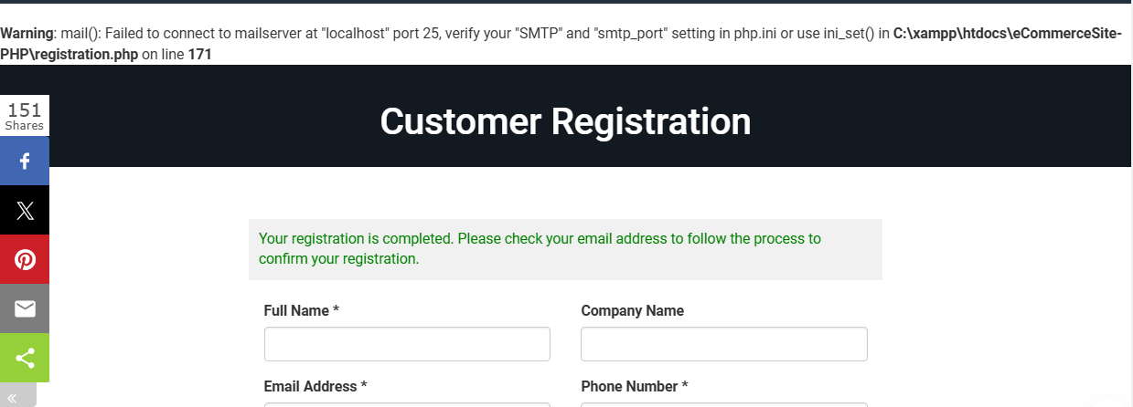

Also, if we input a special character in the “Name” field and fill all required fields, after clicking “Register” the website completely accept the registration requirement. This is a critical error. The error log is on the picture below.

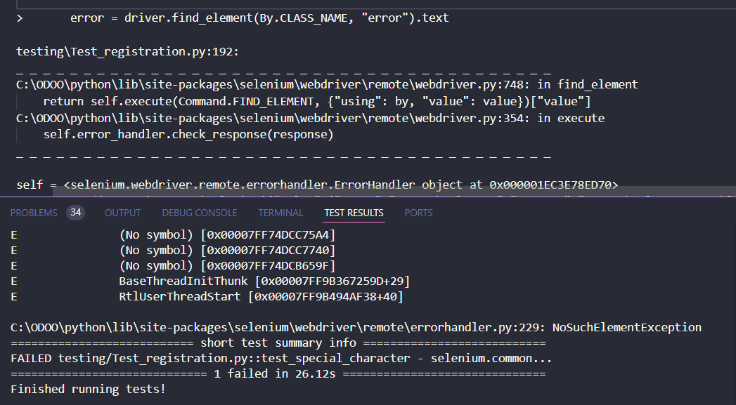

Search Functionality

Test case ID | Description | Steps | Expected Result
TC011 | Test search product and founded that product | - Navigate to http://localhost/eCommerceSite-PHP/index.php  - Enter the keyword “shirt” in the search field  - Click “Search” | The website should show products whose titles contain the keyword
TC012 | Test search product and not founded that product | - Navigate to http://localhost/eCommerceSite-PHP/index.php  - Enter the keyword “agz” in the search field  - Click “Search” | The website should show the label “No result found”
TC013 | Test search space keyword | - Navigate to http://localhost/eCommerceSite-PHP/index.php  - Enter the keyword “ “ in the search field  - Click “Search” | The website should show all products

Add-to-Cart Functionality

Test case ID | Description | Steps | Expected Result
TC014 | Test add a product | - Navigate to http://localhost/eCommerceSite-PHP/login.php  - Enter email address  - Enter password  - Click “Submit”  - Click the category “Men”  - Click the product with the name “Amazfit GTS 3 Smart Watch for Android iPhone”  - Choose color (Optional)  - Click “Add to Cart”  - Click “Cart” | The product in cart must be the same as the product user has added
TC015 | Test remove a product | - Navigate to http://localhost/eCommerceSite-PHP/login.php  - Enter email address  - Enter password  - Click “Submit”  - Click the category “Men”  - Click the product with the name “Amazfit GTS 3 Smart Watch for Android iPhone”  - Click “Add to Cart”  - Click “Cart”  - Click the trash symbol of the product you has added | The website should remove the product you choose from cart
TC016 | Test cart viewing | - Navigate to http://localhost/eCommerceSite-PHP/login.php  - Enter email address  - Enter password  - Click “Cart” | The website should show all products user has added
TC017 | Test increase the quantity of product in cart | - Navigate to http://localhost/eCommerceSite-PHP/login.php  - Enter email address  - Enter password  - Click “Submit”  - Click the category “Men”  - Click the product with the name “Amazfit GTS 3 Smart Watch for Android iPhone”  - Click “Add to Cart”  - Click “Cart”  - Increase the quantity to 4  - Click “Update Cart” | The quantity of the product should be updated in cart
TC018 | Test add more than 1 product | - Navigate to http://localhost/eCommerceSite-PHP/login.php  - Enter email address  - Enter password  - Click “Submit”  - Search random products  - Choose quantity  - Click “Add to Cart” for each product  - Click “Cart” | The name and the quantity of each product in cart is the same as products before user has added.

Checkout Functionality

Test case ID | Description | Steps | Expected Result
TC019 | Test checkout process with the “Bank Deposit” payment method | - Navigate to http://localhost/eCommerceSite-PHP/login.php  - Enter email address  - Enter password  - Click “Submit”  - Click “Update Billing and Shipping Info”  - If that account has not updated the “Billing Address” and “Shipping Address” before, fill all required field  - Click “Update”  - Click the category “Men”  - Click the product with the name “Amazfit GTS 3 Smart Watch for Android iPhone”  - Choose color and quantity (Optional)  - Click “Add to Cart”  - Click “Cart”  - Click “Proceed to Checkout”  - Select Payment Method “Bank Deposit”  - Enter transaction information  - Click “Pay now” | The website should show a successful message about payment
TC020 | Test checkout process with the “PayPal” payment method | - Navigate to http://localhost/eCommerceSite-PHP/login.php  - Enter email address  - Enter password  - Click “Submit”  - Click “Update Billing and Shipping Info”  - If that account has not updated the “Billing Address” and “Shipping Address” before, fill all required field  - Click “Update”  - Click the category “Men”  - Click the product with the name “Amazfit GTS 3 Smart Watch for Android iPhone”  - Choose color and quantity (Optional)  - Click “Add to Cart”  - Click “Cart”  - Click “Proceed to Checkout”  - Select Payment Method “PayPal”  - Enter transaction information  - Click “Pay now” | The website should navigate to PayPal page to complete the payment process

There is a critical error when user checkout with PayPal payment method. To be more specific, when the website navigate to the PayPal page, there is no payment in that page, as user cannot complete the payment process.

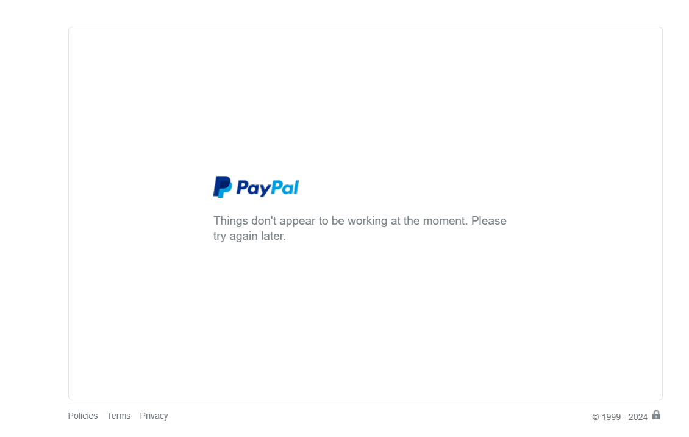

The error log is on the picture below.

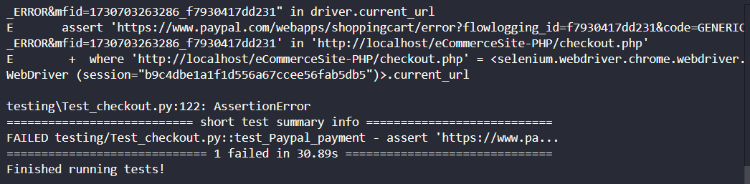

- Test Case Summary Report
- Metrics

Test cases Planned | Test cases Executed | Test cases Passed | Test cases Failed
20 | 20 | 18 | 2

- Type of Testing Performed
Functional Testing

